-- KPIs

-- 1) Total Revenue (How much money did we make this year?)

-- 2) Average Order Value

-- 3) Total Pizzas Sold

-- 4) Total Orders

-- 5) Average Pizzas per Order

-- QUESTIONS TO ANSWER

-- 1) Daily Trends for Total Orders

-- 2) Hourly Trend for Total Orders

-- 3) Percentage of Sales by Pizza Category

-- 4) Percentage of Sales by Pizza Size

-- 5) Total Pizzas Sold by Pizza Category

-- 6) Top 5 Best Sellers by Total Pizzas Sold

-- 7) Bottom 5 Worst Sellers by Total Pizzas Sold

FINDINGS:

-- KPIs

-- 1) Total Revenue for the year was $817,860

-- 2) Average Order Value was $38.31

-- 3) Total Pizzas Sold – 50,000

-- 4) Total Orders – 21,000

-- 5) Average Pizzas per Order – 2

-- QUESTIONS

-- 1) The busiest days are Thursday (3239 orders), Friday (3538 orders) and Saturday (3158 orders). Most sales are recorded on Friday

-- 2) Most orders are placed between 12pm to 1pm, and 5pm to 7pm

-- 3) Classic pizza has the highest percentage sales (26.91%), followed by Supreme (25.46%), Chicken (23.96%) and Veggie (23.68%) pizzas

-- 4) Large size pizzas record the highest sales (45.89%) followed by medium (30.49%), then small (21.77%). XL and XXL only account for 1.72% and 0.12% respectively

-- 5) Classic Pizza accounts for the highest sales (14,888 pizzas) followed by Supreme (11,987 pizzas), Veggie (11,649 pizzas) and Chicken (11,050 pizzas)

-- 6) Top 5 Best Sellers are the Classic Deluxe (2453 pizzas), Barbecue Chicken (2432 pizzas), Hawaiian (2422), Peperoni (2418 pizzas) and Thai Chicken (2371 pizzas)

-- 7) Bottom 5 Worst Sellers are Brie Carre (490 pizzas), Mediterranean (934 pizzas), Calabrese (937 pizzas), Spinach Supreme (950 pizzas) and Soppressata (961).

CONCLUSION:

The outlet should capitalize on Large size Classic, Supreme, Veggie and Chicken pizzas.

Since XL and XXL pizzas account for such a small percentage of their sales (just 1.94%), they can safely get rid of these pizza sizes.

Even though the Brie Carre pizza is the worst seller, it recorded 490 pizzas sold. It would still be a good idea to keep it in the menu.

QUERIES USED:

USE pizza;

SELECT *

from pizzas

-- KPIs

-- 1) Total Revenue

-- a) verify that the price given is for one pizza

SELECT

*

FROM pizzas

WHERE pizza_id = 'big_meat_s'

ORDER BY price DESC;

-- big_meat_s quantity 4

SELECT

*

FROM order_details AS o

JOIN pizzas AS p

ON o.pizza_id = p.pizza_id

ORDER BY quantity DESC;

-- final query

SELECT

round(SUM(quantity * price), 2)

FROM order_details AS o

JOIN pizzas AS p

ON o.pizza_id = p.pizza_id

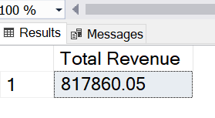

-- 2) Average Order Value

-- total order value/order count

SELECT

SUM(quantity * price)/ COUNT(DISTINCT order_id) AS [Average Order Value]

FROM order_details AS o

JOIN pizzas AS p

ON o.pizza_id = p.pizza_id

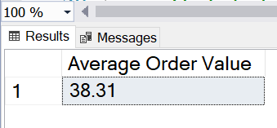

-- 3) Total pizzas sold

SELECT

SUM(quantity) AS [Total Pizzas Sold]

FROM

order_details

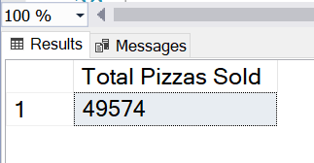

-- 4) Total Orders

SELECT

COUNT(DISTINCT order_id) AS [Total Orders]

FROM

order_details

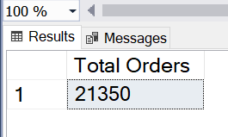

-- 5) Average Pizzas Per Order

-- quantity sold/order IDs

SELECT

ROUND(SUM(quantity)/COUNT(DISTINCT order_id),2) AS [Average Pizzas Per Order]

FROM

order_details

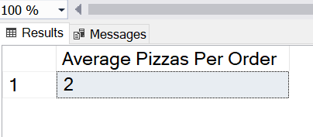

-- Sales analysis

-- 1) Daily Trends for Total Orders

SELECT

FORMAT(date, 'dddd') AS DayOfWeek

,COUNT(DISTINCT order_id) AS total_orders

FROM orders

GROUP BY FORMAT(date, 'dddd')

ORDER BY total_orders DESC

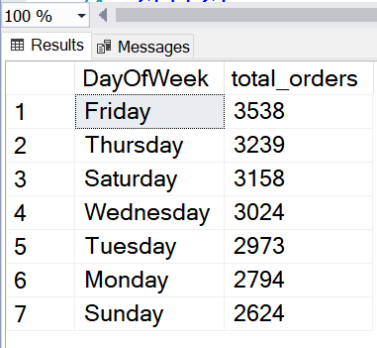

-- 2) Hourly TrendS for Total Orders

SELECT

DATEPART(HOUR, time) AS [Hour]

,COUNT(DISTINCT order_id) AS Total_Orders

FROM orders

GROUP BY DATEPART(HOUR, time)

ORDER BY [Hour]

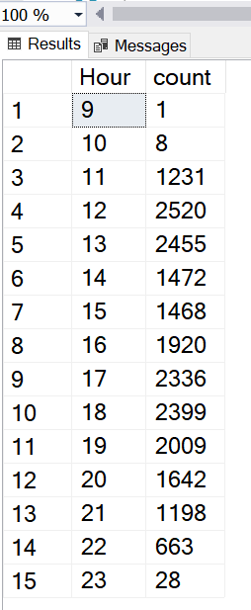

-- 3) Percentage of Sales by Pizza Category

-- a: calculate total revenue per category

-- % sales calculated as (a:/total revenue) * 100

SELECT *

FROM

pizzas

SELECT

category,

ROUND(SUM(quantity * price), 2) AS revenue,

ROUND(SUM(quantity * price) * 100.0 / (SELECT SUM(quantity * price) FROM pizzas AS p2 JOIN order_details AS od2 ON od2.pizza_id = p2.pizza_id), 2) AS percentage_of_sales

FROM

pizzas AS p

JOIN

pizza_types AS pt ON p.pizza_type_id = pt.pizza_type_id

JOIN

order_details AS od ON od.pizza_id = p.pizza_id

GROUP BY

category;

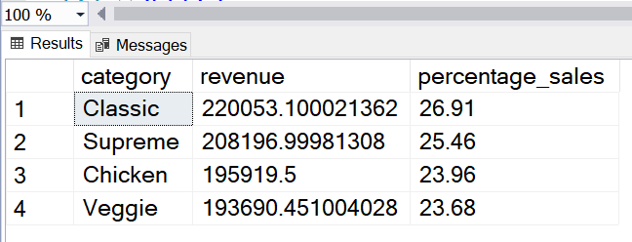

-- 4) Percentage of Sales by Pizza Size

SELECT

size

,ROUND(SUM(quantity * price), 2) AS revenue

,ROUND(SUM(quantity * price) * 100.0 / (SELECT SUM(quantity * price) FROM pizzas AS p2 JOIN order_details AS od2 ON od2.pizza_id = p2.pizza_id), 2) AS percentage_of_sales

FROM

pizzas AS p

JOIN

pizza_types AS pt ON p.pizza_type_id = pt.pizza_type_id

JOIN

order_details AS od ON od.pizza_id = p.pizza_id

GROUP BY

size;

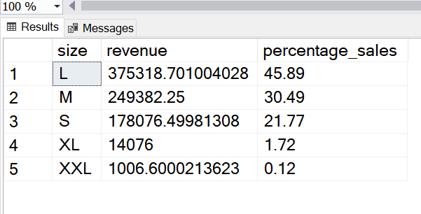

-- 5) Total Pizzas Sold by Pizza Category

SELECT

category

,SUM(quantity) AS quantity_sold

FROM

pizzas AS p

JOIN

pizza_types AS pt ON p.pizza_type_id = pt.pizza_type_id

JOIN

order_details AS od ON od.pizza_id = p.pizza_id

GROUP BY category;

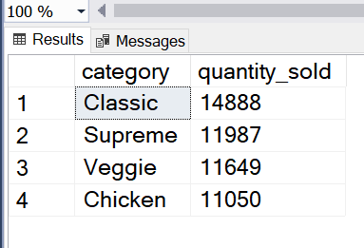

-- 6) Top 5 Best Sellers by Total Pizzas Sold

SELECT top 5

name

,SUM(quantity) AS total_quantity_sold

FROM

pizzas AS p

JOIN

pizza_types AS pt ON p.pizza_type_id = pt.pizza_type_id

JOIN

order_details AS od ON od.pizza_id = p.pizza_id

GROUP BY name

ORDER BY total_quantity_sold DESC;

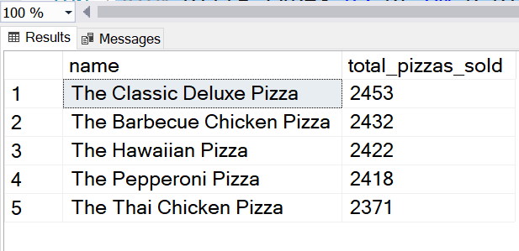

-- 7) Bottom 5 Best Sellers by Total Pizzas Sold

SELECT top 5

name

,SUM(quantity) AS total_quantity_sold

FROM

pizzas AS p

JOIN

pizza_types AS pt ON p.pizza_type_id = pt.pizza_type_id

JOIN

order_details AS od ON od.pizza_id = p.pizza_id

GROUP BY name

ORDER BY total_quantity_sold ASC;

